Requesting a new token in order to get authorized to read and write data to TMDB. We put the api key to postman and using GET method it generated us a new token to use.  
  
Afterwards the request token had to be approved by the user logged in to TMDB. Provided the link

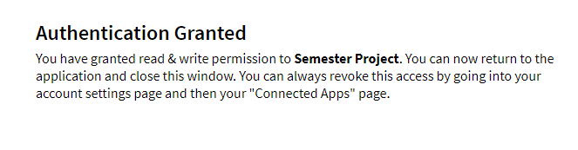https://www.themoviedb.org/authenticate/{REQUEST_TOKEN}

After the authenication we need to generate a Session ID for the user logged in. This way the user can see their facorites and rates movies, what they have put.